Executive Summary
What Drives Property Price — Analysis of 300 Listings

Purpose
Analyzed 300 property listings to identify which attributes — size, location, type, age, bedrooms, bathrooms — actually influence sale price, and confirmed the results with statistical testing rather than visual impressions alone.

Key Findings
- Property size (Area) is the single biggest driver of price — larger properties command consistently higher prices.
- Location matters significantly — City Center properties sell for roughly double the price of Rural properties on average.
- Property type (House, Villa, or Apartment) does not meaningfully affect price once other factors are accounted for.
- Number of bedrooms, bathrooms, and property age have little to no measurable effect on price.

Business Implication
Pricing and valuation efforts should prioritize Area and Location as the primary factors. Property_Type, bedroom/bathroom count, and age can largely be deprioritized in pricing models — they add complexity without adding predictive value.

At a Glance
Factor | Effect on Price
Area (size) | Strong — biggest driver
Location | Strong — City Center > Suburb > Rural
Property Type | None (not statistically significant)
Bedrooms / Bathrooms / Age | Minimal to none

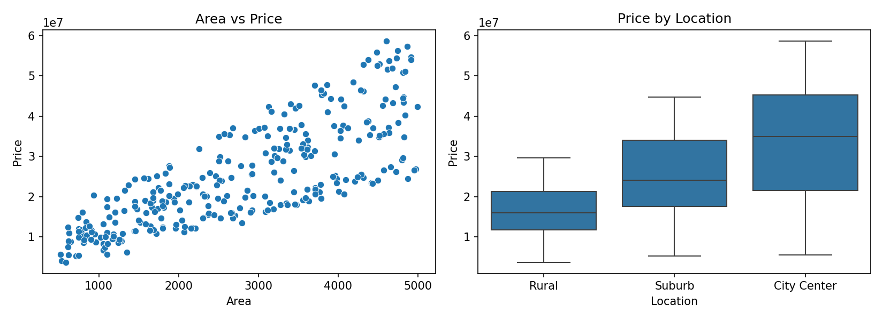

Confidence
Findings are statistically validated (p < 0.05 for Area and Location effects) using a sample of 300 property records. Full methodology and detailed statistical results are available in the accompanying technical report.

